Part 1; Configuring network interfaces and network settings
Viewing network interfaces use the command; nmcli device status
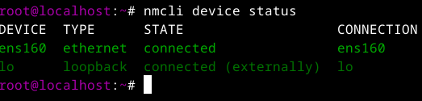
Viewing IP details use the command; nmcli device show devicename
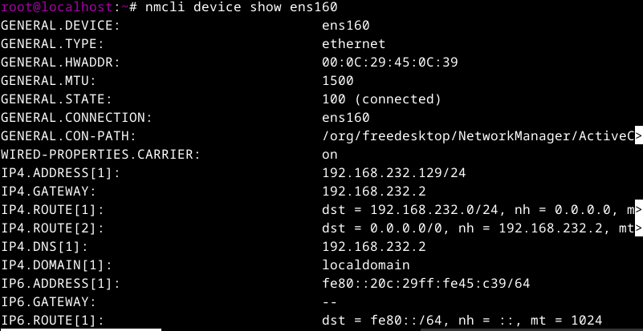
NOTE; We can also use the command; nmcli connection show to view network interfaces and the command; ip addr show to view IP details
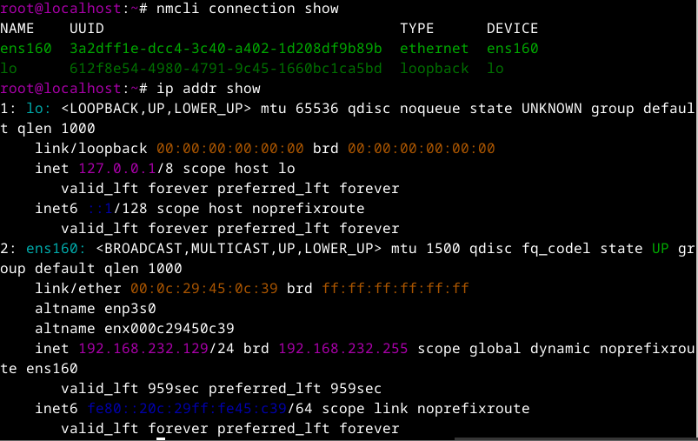
Viewing available connection files use the command; ls /NetworkManager/system-connections/
Editing available connection file use the command; nano /etc/NetworkManager/system-connections/filename

